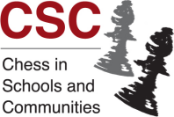 Chess Tutor Training Course

Chess in Schools and Communities (CSC), a UK charity, is running a one-day course in Cardiff designed for new chess tutors, teachers, mentors, parents, and anyone who is involved or wants to become involved in junior chess.

Date: Thursday 4 May 2017
Venue: Park Inn by Radisson Cardiff City Centre, Marry Ann Street, Cardiff, CF10 2JH
Time: 10.00 - 17.00
Cost: £60 unless involved with a CSC school in which case there is no charge
To register go to the Chess In Schools’ website and follow the links to Courses and then
Tutor Training Courses. http://www.chessinschools.co.uk/training_courses.htm

No teaching or chess playing experience is required to attend. Lunch is included. For further information contact Sarah Kett on (029) 2061 3870.

